MAINTENANCE, REPAIR & OPERATIONS (MRO)
MDOT River Raisin Watershed Bank Site
Cover Crop and Buffer Strip Installation

MDOT ENVIRONMENTAL SERVICES SECTION

LOCATION SPECIFICATION SHEET (LSS)
RFP NO.: 260000001946

PART I – PLACE OF SERVICES REQUESTED

Bidder Name: Location: MDOT University Region
CONTRACT INFORMATION
ESTIMATED CONTRACT START DATE: |  |  |  | CONTRACT END DATE:
CONTRACTING AGENCY NAME: |  | MDOT Environmental Services Section
BUILDING NAME and NUMBER: |  | Van Wagoner Building
BUILDING ADDRESS: |  | 425 West Ottawa Street, Lansing, Michigan 48933
REGION / COUNTY: |  | University Region / Washtenaw County
PROCUREMENT CONTACT INFORMATION
PROCUREMENT OFFICE NAME: |  | MDOT CONTRACT SERVICES DIVISION, PURCHASING UNIT
PROCUREMENT OFFICE CONTACT NAME: |  | ReChelle Kendrick |  | CONTACT PHONE #: |  | 517-335-5905
PROCUREMENT OFFICE CONTACT E-MAIL: |  | KendrickR1@michigan.gov
PROGRAM MANAGER (PM) NAME: |  | Jeremie Wilson |  | CONTACT PHONE #: |  | 517-281-9837
PM CONTACT E-MAIL: |  | WilsonJ3@michigan.gov
LOCATION INFORMATION
COUNTY | Washtenaw |  | SITE LOCATION DIRECTIONS |  | Located 5 miles east of Manchester, 1 mile east of Lima Center Road on the south side of Braun Road. Access is off Braun Road.
TOWNSHIP | Bridgewater Township
TRS – ¼ SECTION | T04S, R04E, Sec: 23

PART II: SITE LOCATION MAP AND PLANTING AREA
River Raisin Watershed Bank Site

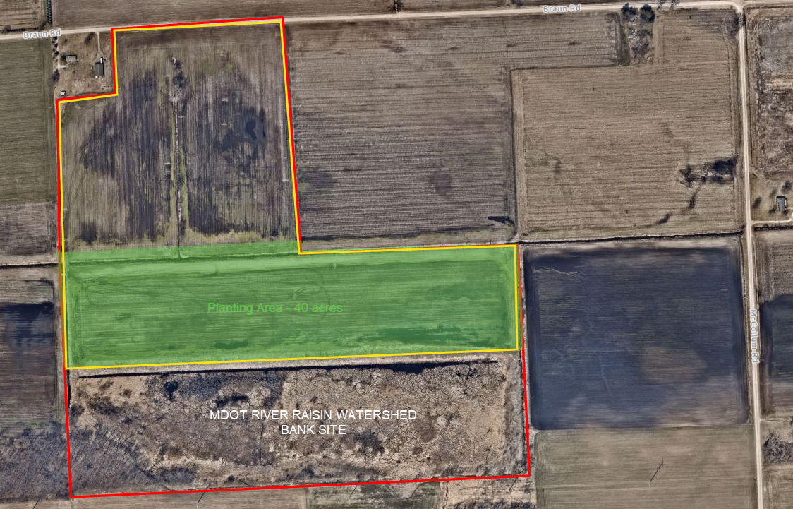

PART III: SCHEDULE B – PRICING

River Raisin Watershed Bank Site

Bidder Name:

- Price proposals must include pricing for the proposed Contract Activities using table below. The pricing schedule should be submitted in this modifiable format; however, you may also submit an additional pricing schedule in a non-modifiable format (e.g., PDF). Failure to complete the pricing schedule as requested may result in disqualification of your proposal. Shape files of treatment areas will be shared digitally with applicator(s) once bids are reviewed and accepted for award.

- Listed Total Cost must include Materials, Staging, and Application via aerial drone.

- By submitting its proposal, the Contractor certifies that the prices were arrived at independently.

- Georeferenced shape files of treatment areas will be shared digitally with applicator(s) once bids are reviewed and accepted for award.

- The Contractor is encouraged to offer quick payment terms. The number of days must not include processing time for payment to be received by the Contractor's financial institution.

Quick payment terms: ________ % discount off invoice if paid within ________ days after receipt of
invoice.

DESCRIPTION OF CONTRACT ITEM | COST
MDOT Native Upland Seed Mixture (See Schedule A) – 40 acres
Seed Installation – 40 acres
Miscellaneous – debris removal and field preparation in seeding area
TOTAL
*The State is not obligated to purchase in the acreage listed.

